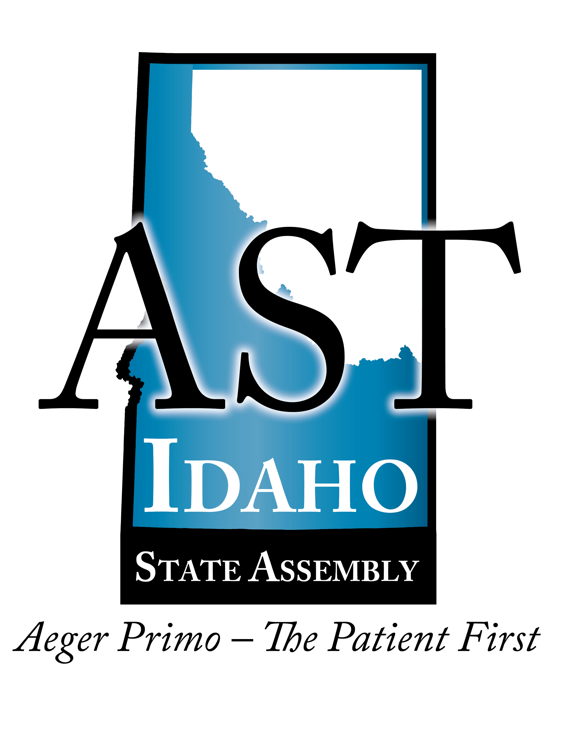

**Learning Objectives:**

1. Differences in permanent OR and field OR setup
   1. How is a field OR set up?
   2. Location, safety concerns
2. How to treat blast injuries
3. How you can translate the field knowledge to the OR and daily living

**AGENDA**

**Free CE Event**

**January 08, 2019**

|  |  |
| --- | --- |
| 7:00pm | Registration  Dinner (if purchasing) |
| 7:30-8:30pm | **Matt Smith, CRNA**  *Austere Surgical Sites/Blast Injury* |
| 8:40-9:00pm | Evaluations and CE forms distributed  Dismissal |

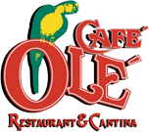

Dinner available for purchase before the speaking event.

Café Ole`

Boise Towne Square, 210 N Milwaukee St, Boise, ID 83704

Join us for a one-hour FREE CE event!

**7:30pm**

Registration at 7:00pm

**Matt Smith, CRNA**

**Austere Surgical Sites/Blast Injury**

## January 08, 2019

Free CE Event

IDSAST